DRAFT PROJECT PROPOSAL – EXCHANGE OF AUDIO INFORMATION VIA WIRELESS TECHNOLOGY

AUTHOR: KAIRU JOSHUA WAMBUGU

REGISTRATION NUMBER: CS281-0720/2011

DATE: Thursday, March 3, 2016

Background/Introduction

This project aspires to create a method through which two devices might communicate via wireless technology at a cheaper cost. The project aims to achieve this goal by using Wi-Fi communication between two mobile devices. The next few pages outline the system analysis and system design processes behind the system.

System Analysis

In this section, we will look at two requirements needed by any computer system:
- Functional requirements.
- Non-functional requirements.

These are discussed starting now.

Functional requirements.
The system has two functional requirements.
First, it should allow two smartphones to connect to each other over wireless. This should be done without the use of an intermediary device. This will be achieved using relevant code on both phones, as well as a WiFi connection between the two.
Second, the system should allow audio data to be transferred between the two connected phones. This is also to be done using code.

Non-Functional requirements.
These are also two.
First, the system should be secure. This is important because audio can easily be recorded and misused by malicious individuals. Security over WiFi has always been a challenge. Since we cannot control the circumstances and motives of all who will end up using this system, we can only hope that they will set up their WiFi connections over a protected wireless link. During the implementation phase of this project, we plan to use a connection protected by WPA-PSK2.
Second, the system should provide for audio clarity. The sound heard by individuals on both ends of the device should be clear enough for them to recognize. We hope that the inbuilt sound processing systems of the devices we will use have this facility in place.
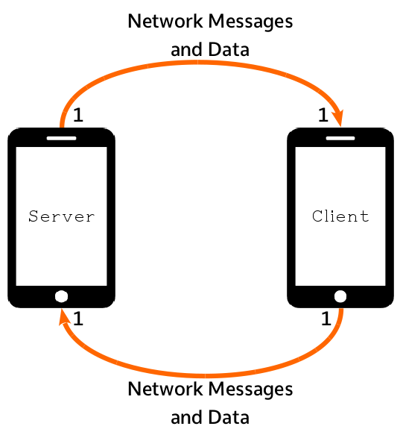Illustration 1: Network Topology Diagram

System Design

To show the design of this system, we will use the following diagrams:
- The Network Topology Diagram;
- Class Diagrams;
- Activity Diagrams;
- The Sequence Diagram; and
- The Navigation Diagram.

The Network Topology Diagram
Since the project is centered on creating a connection between two devices, we have to outline how the network will look. This is highlighted in the network topology diagram in Figure 1.
The figure shows two phones serving as server and client. The numbers close to the points where arrows touch the phones indicate the number of servers and clients allowed to communicate with each other at a moment. The 1's close to where the arrows touch the phones show that there can only be one server communicating with one client at any particular point in time.
This understanding is important as we design the system further since it ensures that we will not focus on broadcasts, multicasts, or any other one-to-many communication form.

Class Diagrams
Class diagrams show the various classes used in a software system as well as how these classes are related.
Our system has a total of 11 classes. These classes are explained below.
- HomeActivity class. This class is the point at which the user lands when they fire up the system.
The class diagram for the HomeActivity class is seen in Figure xxx.
- ReceiveCallActivity class. This class waits for a call to arrive and processes the requests of the caller.
The class diagram for the ReceiveCallActivity class is seen in Figure xxx.
- IncomingCallActivity class. This class alerts the user to an incoming call. It allows the user to their accept or reject the call.
The class diagram for the IncomingCallActivity class is seen in Figure xxx.
- CallInSessionActivity class. This is the class where audio data is sent and received between the two connected devices.
The class diagram for the CallInSessionActivity class is seen in Figure xxx.
- MakeCallActivity class. This class allows the user to select a contact to call.
The class diagram for the MakeCallActivity class is seen in Figure xxx.
- CallingActivity class. In this class, the user calls the contact selected in the MakeCallActivity class. If the contact is not a viable receiver or is busy, this class informs the user of the same. When the called individual picks up, this class directs the user to an instance of CallInSessionActivity.
The class diagram for the CallingActivity class is seen in Figure xxx.
- Contact class. This class represents a contact on the contact list found in MakeCallActivity.
The class diagram for the Contact class is seen in Figure xxx.
- SearchForContactsThread class. This class extends the Java Thread class and is used to search for contacts from available hotspots. Searching for contacts is fairly expensive in terms of time. This means that doing it from the same thread as the UI thread would make the app look like it is hanging. To avoid this circumstance, in this class we search for contacts using a thread different from the UI thread.
The class diagram for the SearchForContactsThread class is seen in Figure xxx.
- WifiStateChangeBroadcastReceiver class. This class extends the Android BroadcastReceiver class. Whenever the state of an Android device's WiFi changes, the new state is broadcast throughout the applications of the device. To receive that broadcast, an application needs to extends the BroadcastReceiver class. Since our system needs to be informed the moment WiFi is turned on so as to scan for contacts, we use the WifiStateChangeBroadcastReceiver class and configure it to receive the “WiFi on” state.
The class diagram for the WifiStateChangeBroadcastReceiver class is seen in Figure xxx.
- SendRecordedSoundTimerTask class. This class extends the Android TimerTask class. TimerTask classes are used to perform actions at specific intervals of time. We use the SendRecordedSoundTimerTask class to record audio every second and to send the recorded audio every second.
The class diagram for the SendRecordedSoundTimerTask class is seen in Figure xxx.
- SocketServerThread class. Like the SearchForContactsThread class above, this extends the Java Thread class. It is used by the ReceiveCallActivity class to listen for any connections coming in from the CallingActivity class.
The class diagram for the SocketServerThread class is seen in Figure xxx.
A summarized class diagram showing relationships between classes is called an elided class diagram. Our elided class diagram is seen in Figure xxx. The next few paragraphs explain the elided diagram.
To begin with, we see HomeActivity can start one of either ReceiveCallActivity or MakeCallActivity. HomeActivity cannot start both these two classes at the same time.
The filled diamond on the line connecting ReceiveCallActivity to SocketServerThread tells us that ReceiveCallActivity has a SocketServerThread instance and that the SocketServerThread instance cannot exist without the ReceiveCallActivity instance. This is so because the SocketServerThread class exists to assist the ReceiveCallActivity class connect to clients. The ReceiveCallActivity can start only one instance of the IncomingCallActivity class.
IncomingCallActivity can start only one instance of CallInSessionActivity. There is not much else IncomingCallActivity can do in terms of inter-class interactions.
MakeCallActivity has one SearchForContactsThread object and one WifiStateChangeBroadcastReceiver object. However, it can have as many Contact objects as possible. MakeCallActivity uses a SearchForContactsThread object to search for contacts and display them. It uses a WifiStateChangeBroadcastReceiver instance to be alerted whenever the WiFi is turned on. And MakeCallActivity can have as many Contact objects as possible since we cannot determine beforehand how many hotspots there will be around the place of application execution. The last thing about MakeCallActivity is that it can start only one instance of the CallingActivity class.
Just like IncomingCallActivity, CallingActivity can start only one CallInSessionActivity object and can do nothing much else.
From the diagram, we see that CallInSessionActivity instances can be instantiated by either IncomingCallActivity instances or CallingActivity instances. Each of those last two mentioned classes can start only one CallInSessionActivity object each. CallInSessionActivity has a SendRecordedSoundTimerTask object which it uses to send recorded sound every second and to receive recorded sound and play it every second.

Activity Diagrams
Activity diagrams highlight the order in which instructions are executed in an instance of a class.
In our case, all classes which have a set of instructions to execute have their activity diagrams drawn. Explanations are as follows.
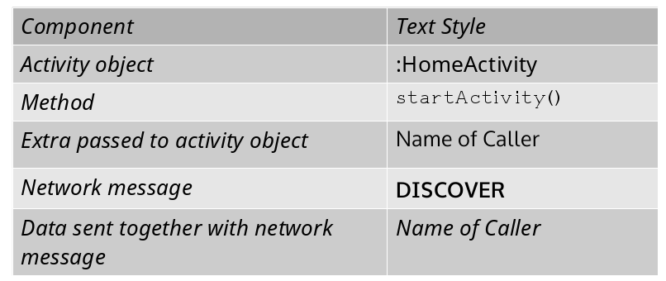
- HomeActivity class.
The activity diagram for the HomeActivity class is seen in Figure xxx.
The class starts off displaying to the user a UI that allows him/her to choose which role they want to be: caller or receiver. If the user chooses to make a call, the class starts the MakeCallActivity class. If the user chooses to receive a call, the class starts the ReceiveCallActivity. After processing user requests, HomeActivity terminates.
- ReceiveCallActivity class.
The activity diagram for the ReceiveCallActivity class is seen in Figure xxx.
We begin by displaying to the user that the system is waiting for a call. We then begin listening for any incoming connections using an instance of the SocketServerThread class. We keep doing this listening until we receive a connection from the CallingActivity class. On receiving such a connection, we start an instance of the IncomingCallActivity class and pause the ReceiveCallActivity class. An option is there to terminate the ReceiveCallActivity if necessary.
- IncomingCallActivity class.
The activity diagram for the IncomingCallActivity class is seen in Figure xxx.
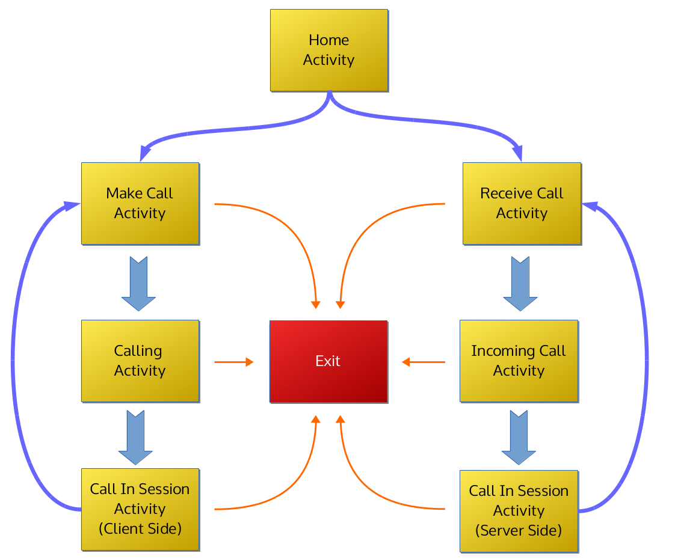
In this class, we start by displaying the needed UI so that the user might know that a call is incoming. We then retrieve references to the connection established in the parent activity of this class. The parent activity is the ReceiveCallActivity since instances of the IncomingCallActivity class are started off by instances of the ReceiveCallActivity class. Part of the UI of the IncomingCallActivity class contains two buttons: one for accepting the incoming call and the other for rejecting it. If the user taps the “Accept” button, the IncomingCallActivity class starts a CallInSessionActivity activity then terminates. If the user selects “Reject” then IncomingCallActivity simply terminates. In the latter case, since IncomingCallActivity was started by ReceiveCallActivity and since ReceiveCallActivity had been paused after starting IncomingCallActivity, ReceiveCallActivity is resumed.
- CallInSessionActivity class.
The activity diagram for the CallInSessionActivity class is seen in Figure xxx.
This class begins by initializing the speaker and mute to be off. It sets up the display, initializes the media recorder used for recording sound and initializes the media player used to play sound. It also gets references to the previously established connection. These references come from the class that started this class. As we saw in the class diagrams, CallInSessionActivity can be started by either CallingActivity (from the caller's side) or IncomingCallActivity (from the receiver's side). Either parent class has references to the established network connection and passes these to the CallInSessionActivity class. The UI in CallInSessionActivity has a button for ending the call. As long as this button is not clicked, the class records sound and sends it to the CallInSessionActivity instance on the other side of the network. The class also receives sent sound and plays it. As soon as the end button is clicked, the class terminates.
- MakeCallActivity class. This class allows the user to select a contact to call.
The activity diagram for the MakeCallActivity class is seen in Figure xxx.
We begin by displaying a user interface which will show the user the contacts available for him/her to call and allow the user to scan for contacts. The class also gets the SSID of the user's device. This will be used to identify the user when he/she calls another. After this, the class initializes a SearchForContactsThread object, which will be used to search for contacts when the user elects to scan for some. The final initialization step is to turn on the WiFi. If the user scans for contacts and none are found, they can keep scanning for them. Any contacts that the class finds will be displayed in a list. When the user selects a contact to call, MakeCallActivity establishes a network connection with the selected contact, starts CallingActivity, then pauses itself. The user has the option of eventually terminating this class if he/she sees fit.
- CallingActivity class.
The activity diagram for the CallingActivity class is seen in Figure xxx.
As usual for an Activity class, this class begins by displaying the relevant UI. It then waits for five seconds to simulate the behavior users might expect during the making of a call. Without this delay, the app will execute very quickly and that might leave users a bit confused. After the five seconds, we get references to the previously set up connection. This connection is the one set up at MakeCallActivity. Then we process the messages coming from the IncomingCallActivity, which by this time should be running on the device on the other side of the network. If the IncomingCallActivity sends a “PICKED_UP” message, this means that the other user has picked up the call and so we start CallInSessionActivity. If we receive a “REJECTED” instead, this means that the user does not desire to communicate now so we change the UI inform the caller of this. After processing the messages, we terminate the CallingActivity instance, leaving either the newly started CallInSessionActivity instance or the previously paused MakeCallActivity instance to continue interacting with the user.
- SearchForContactsThread class.
The activity diagram for the SearchForContactsThread class is seen in Figure xxx.
This class starts out by disabling the button used to scan for contacts. This is done to show the user that they cannot scan until the previous scan request has been fully processed. Thankfully, processing scan requests in a separate thread takes a rather short time. The class then initializes a set of Contact instances from the hotspots found after scanning. After this, the class populates the ListView of MakeCallActivity with this list of Contacts. The last thing done by this class is enabling the scanning button.
- WifiStateChangeBroadcastReceiver class.
The activity diagram for the WifiStateChangeBroadcastReceiver class is seen in Figure xxx.
What happens in this class is fairly simple. We get the wait for the WiFi state to change. It changes to the state where it is enabled, we start searching for available contacts and then terminate after doing so.
- SendRecordedSoundTimerTask class.
The activity diagram for the SendRecordedSoundTimerTask class is seen in Figure xxx.
This class is very important for the sending and receiving of audio data between CallInSessionActivity instances. What happens in this class is generally controlled by a flag which oscillates between the “record” and the “stop recording and send recorded file” states. Since the class does its job based on fixed intervals of time, if timing is canceled then the class terminates. The class starts off with the flag set to the “record” state. In this state, the class starts recording sound for a fixed amount of time. When that is finished, it sets the flag to the “stop recording and send file” state. As long as the timing is not canceled, processing continues. The value of the flag is read and found to be “stop recording and send file”. As long as the timing is not canceled, processing continues. With timing still not canceled, the class checks the flag, sees that it reads “record”, and goes about executing the “record” state. This cycle goes on until the timing gets canceled.
- SocketServerThread class.
The activity diagram for the SocketServerThread class is seen in Figure xxx.
This class is where most of the networking is done. We first attempt to connect to a client. If the attempt fails, we inform the user of a failure and then we keep waiting for a connection. If we are able to set up the connection, we then get references to that connection. These references are important since they help us send data to and receive data from device at the other end. With the references acquired, we can now start processing requests from the connected party.

The Sequence Diagram
An interaction diagram is used to show how different objects in a system interact
with each other. The interaction diagram for this project is shown in Figure 2.
The table in Figure 3 explains what each of the text styles in the interaction
diagram represents.
Below is a brief explanation of what happens.
- HomeActivity: The system starts at this activity. The user chooses if they want to make a call or receive a call. Depending on the user’s choice, the system calls a startActivity() for an instance of either the MakeCallActivity class or the ReceiveCallActivity class. After doing this, the HomeActivity activity finishes and closes down.
- MakeCallActivity: This activity is started when the user decides to make a call. Here, the user can select which individual to call. When the individual to be called is chosen, the MakeCallActivity activity calls the CallingActivity activity which will attempt to call the chosen individual. The interaction diagram shows that two extras are passed to the CallingActivity activity. An extra is a piece of data passed between Android activities. These two extras are the name of the called individual as well as the name of the individual calling. After starting the CallingActivity activity, the MakeCallActivity activity suspends itself but does not close down.
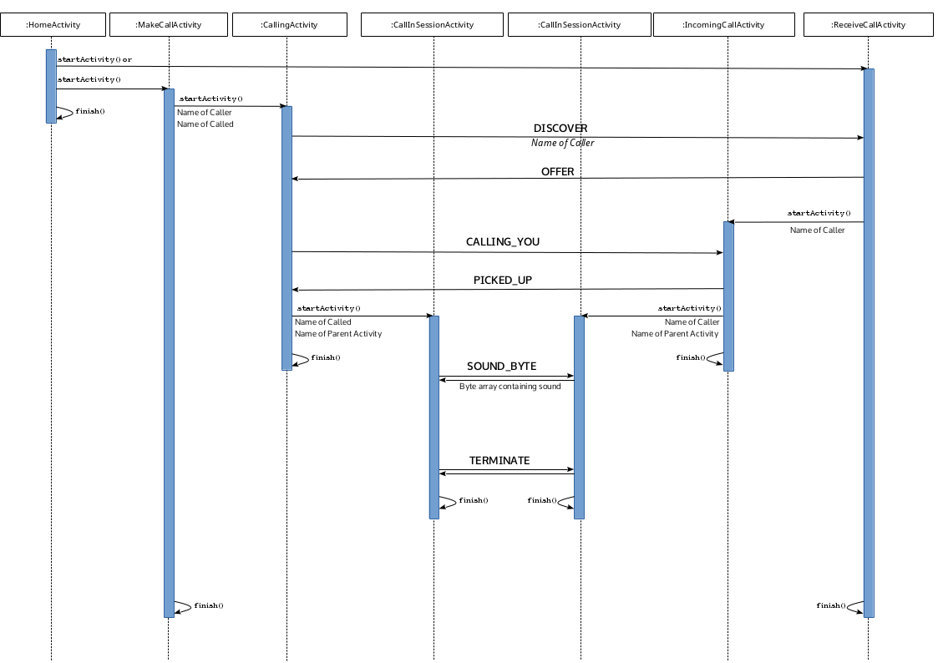Illustration 2: The Interaction Diagram

- CallingActivity: This activity sends a “DISCOVER” network message to the ReceiveCallActivity activity of the individual being called. Along with the “DISCOVER”, the CallingActivity activity sends the name of the caller to the ReceiveCallActivity activity. The ReceiveCallActivity activity responds with an “OFFER” which confirms that it is active and has received the name of the called. As the diagram shows, the ReceiveCallActivity instance starts an IncomingCallActivity activity as soon as it sends the“OFFER”. The CallingActivity activity then sends a “CALLING YOU” network message, which will be received by an instance of the IncomingCallActivity. When the IncomingCallActivity activity sends the CallingActivity activity a “PICKED UP” in response to the “CALLING YOU”, the CallingActivity activity starts an instance of the CallInSessionActivity activity. The CallingActivity passes extras to the CallInSessionActivity containing the name of the called individual as well as the name of the parent activity. Since the user got to the CallInSessionActivity activity via the MakeCallActivity activity, the parent activity in this case is the MakeCallActivity. After passing these extras, the CallingActivity activity finishes and closes down. Remember that the MakeCallActivity instance is still suspended in the background.
- ReceiveCallActivity: This activity is started when the user decides to wait to receive a call. When the ReceiveCallActivity activity receives a “DISCOVER” from a CallingActivity instance, it responds with a “OFFER” and starts an IncomingCallActivity instance – passing an extra containing the name of the caller. After starting the IncomingCallActivity activity, the ReceiveCallActivity activity suspends itself but does not close down.
- IncomingCallActivity: This activity waits for a “CALLING YOU” from the CallingActivity activity and responds to it with a “PICKED UP” as soon as the called individual picks up the call. After sending the “PICKED UP” the IncomingCallActivity instance starts the CallInSessionActivity activity, passing extras containing the name of the caller and the name of the parent activity. Since the user got to the CallInSessionActivity activity via the ReceiveCallActivity activity, the parent activity in this case is the ReceiveCallActivity. After passing these extras, the IncomingCallActivity activity finishes and closes down. The ReceiveCallActivity instance still remains suspended in the background.
- CallInSessionActivity: Here is where the actual voice transfer happens. CallInSessionActivity instances on the side of the caller and the called alternate in sending sound snippets. They do this by sending to each other a “SOUND BYTE” network message and a byte array containing a sound snippet immediately after that. This happens in fixed intervals so that sound is heard continuously. When the users decide to end the call, both CallInSessionActivity instances send each other “TERMINATE” network messages and close down by calling finish(). The system then goes back to the corresponding background activity, either MakeCallActivity for the caller or ReceiveCallActivity for the person being called.

The Navigation Diagram
An application’s navigation diagram shows how a user can maneuver through the said application. Figure 3 shows the navigation options available to the user of the application being created in this project.
The user starts off at the HomeActivity activity and selects whether to make a call or to receive a call.
If, on the one hand, the user elects to make a call, they are directed to the MakeCallActivity activity where they choose a contact to call. Choosing a person to call leads them to the CallingActivity activity where the system attempts to connect to the phone being called. Successful connection leads to the user getting to the CallInSessionActivity activity where they can talk with the other individual. As soon as the call ends, the user is returned to the MakeCallActivity activity. Unsuccessful connection returns the user to the MakeCallActivity activity.
If, on the other hand, the user decides to receive a call, they are taken to the ReceiveCallActivity activity where they wait for an individual to call them. When a call comes in, the user is taken to the IncomingCallActivity activity where they can decide to reject or accept the call. Should the user reject the call, they are returned to the ReceiveCallActivity activity. Should the user accept the call, they are presented with the CallInSessionActivity activity where they can talk with the person on the other side of the line. At the end of the call, the user is taken back to the ReceiveCallActivity activity to wait for another call.
The orange arrows show that it is – at least currently – possible for the user to exit the system at any time.

